### Facebook

* Notifications are primarily kept in a separate menu, though updates can **also show up in the newsfeed**.
* Updates are indicated with a red flag that has a number inside noting how many updates there have been.
* Clicking on a notification will take you to a separate page or section of the site with the full content.
* Notification types
  + Someone else has done something:
    - Written on your wall
    - Commented on a photo
    - Tagged you in a photo
    - Indicated they are interested in an event
  + To remind you of something
    - You have an event
    - You have memories to look back on
    - Wish someone a happy birthday
  + Facebook does not chronicle things you’ve done (written on someone’s wall, wished someone a happy birthday) outside of daily anniversary reminders.

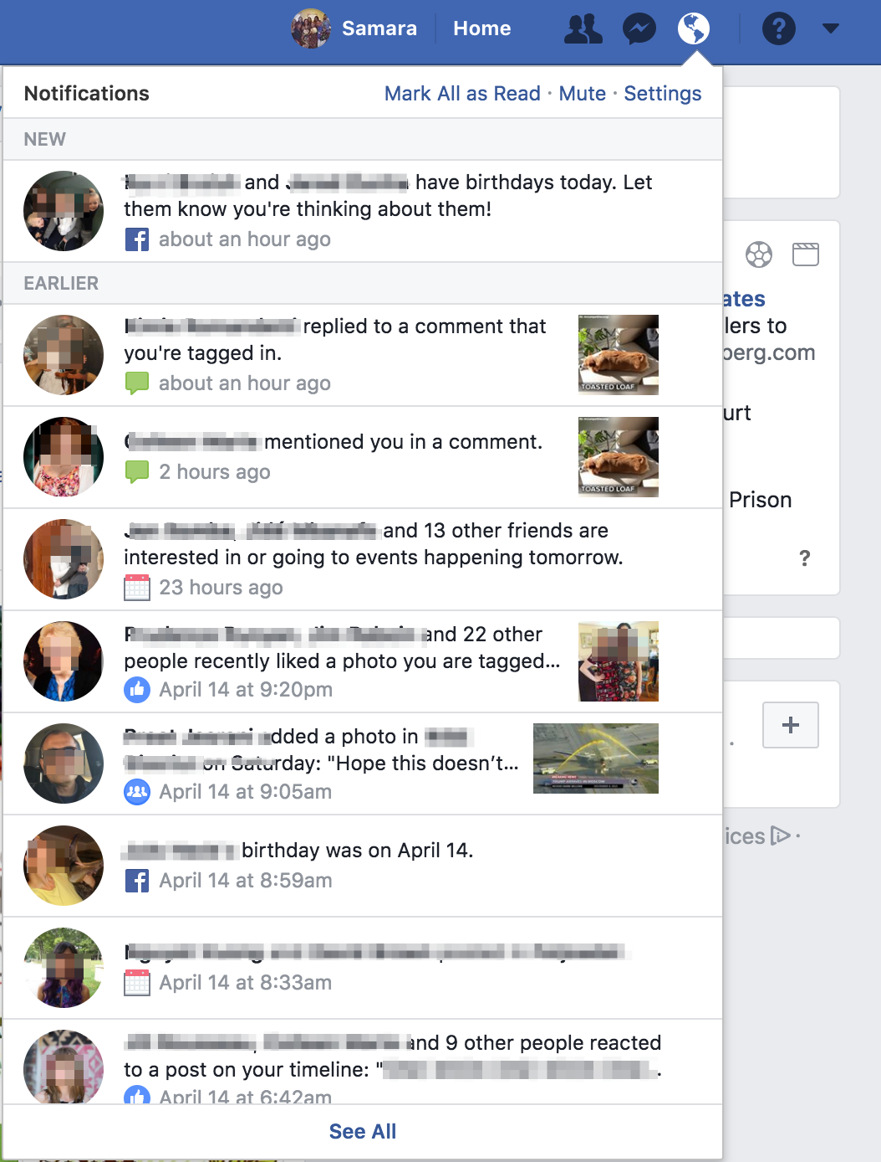

* **See All**  goes to a page where all notifications are listed on a page that continually loads as you scroll. It’s hard to tell how far back notifications go.

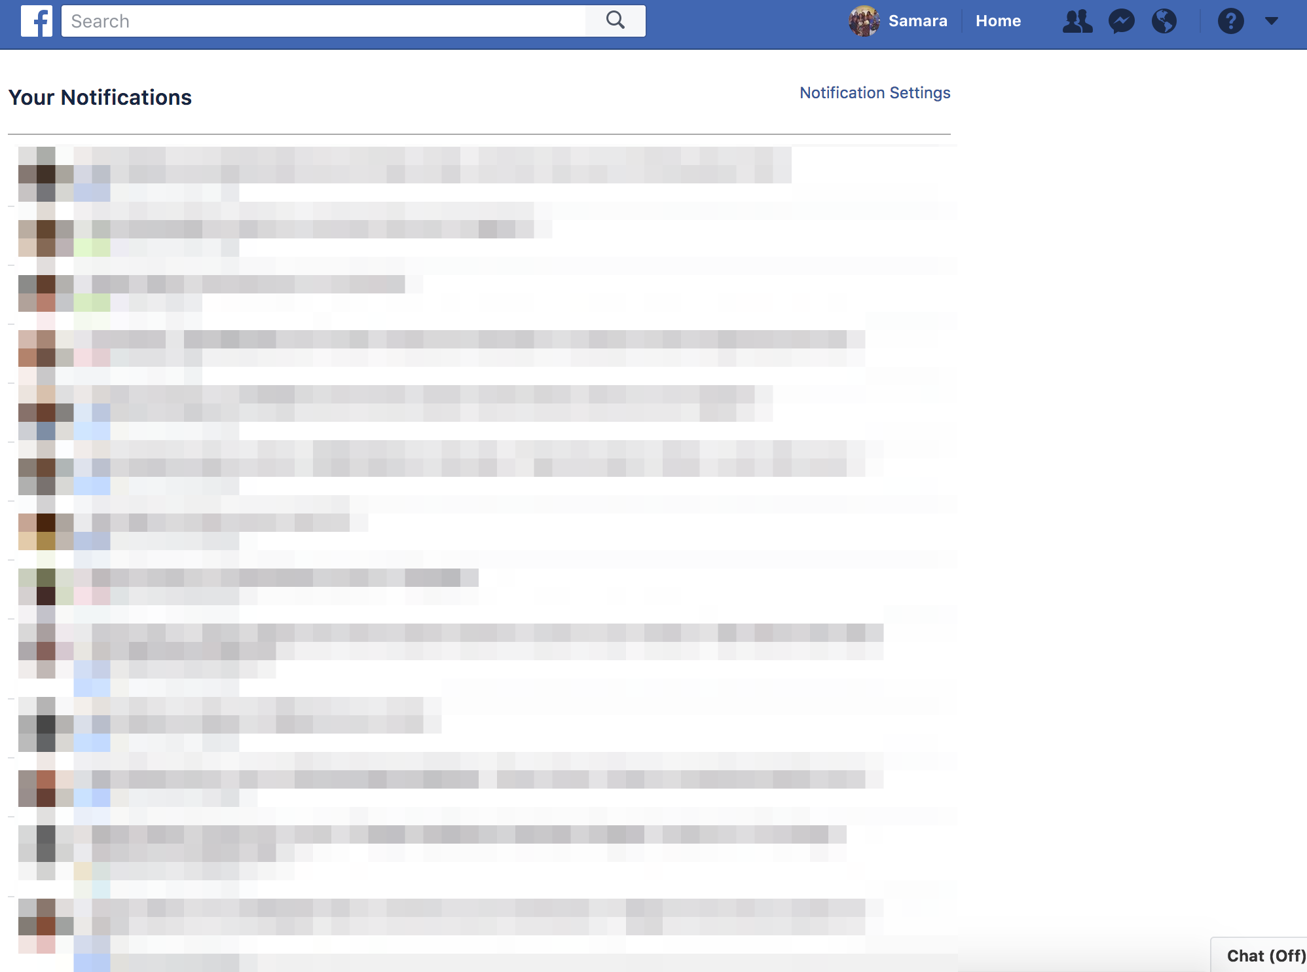

* Notification Settings are linked to from the full list of notifications as well as a general Settings page.

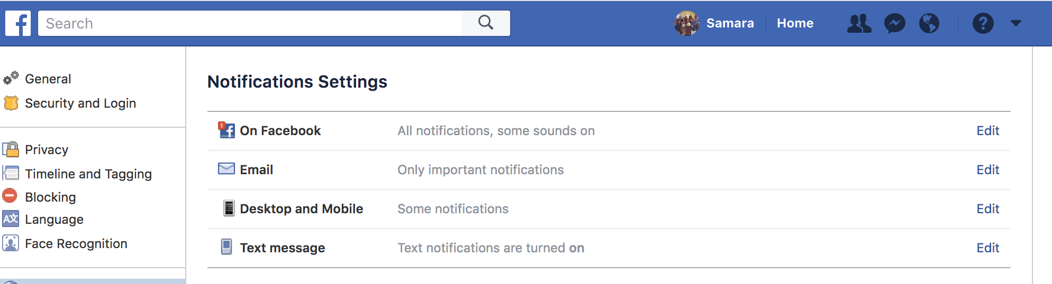

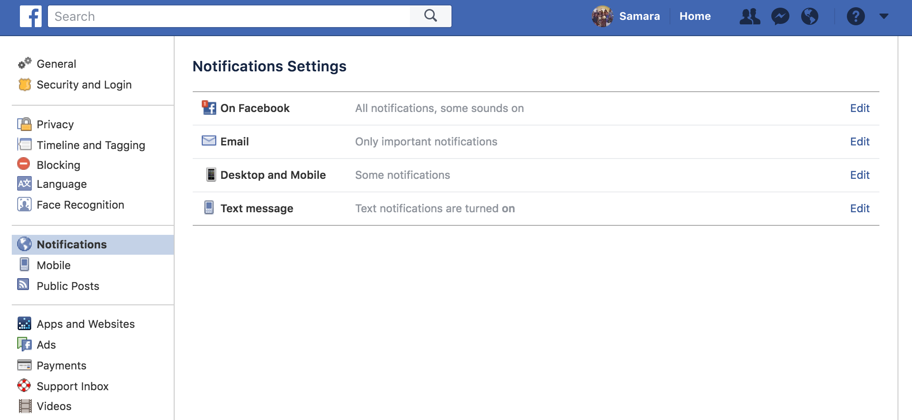

* Facebook does allow the option to toggle some in-app notifications on and off, or to otherwise customize them to the user’s liking

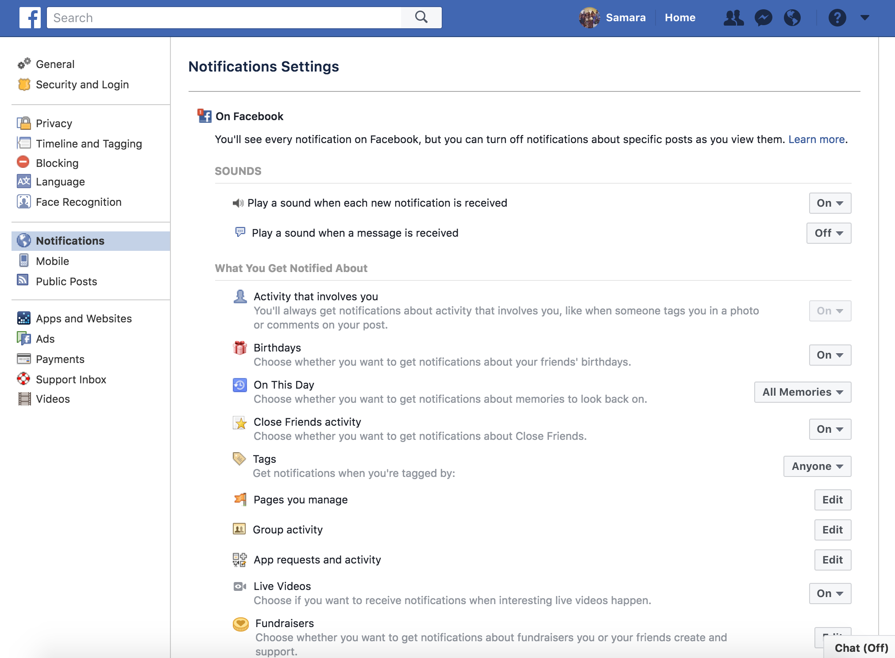

* For email notifications, Facebook let’s you unsubscribe from all, and turn on individually for specific kinds of notifications since there are TONS.
  + **For Vets.gov**, what is the line between what we let people opt out of and what is an automatic notification? Do we need to allow the option to turn off in-app notifications, too?

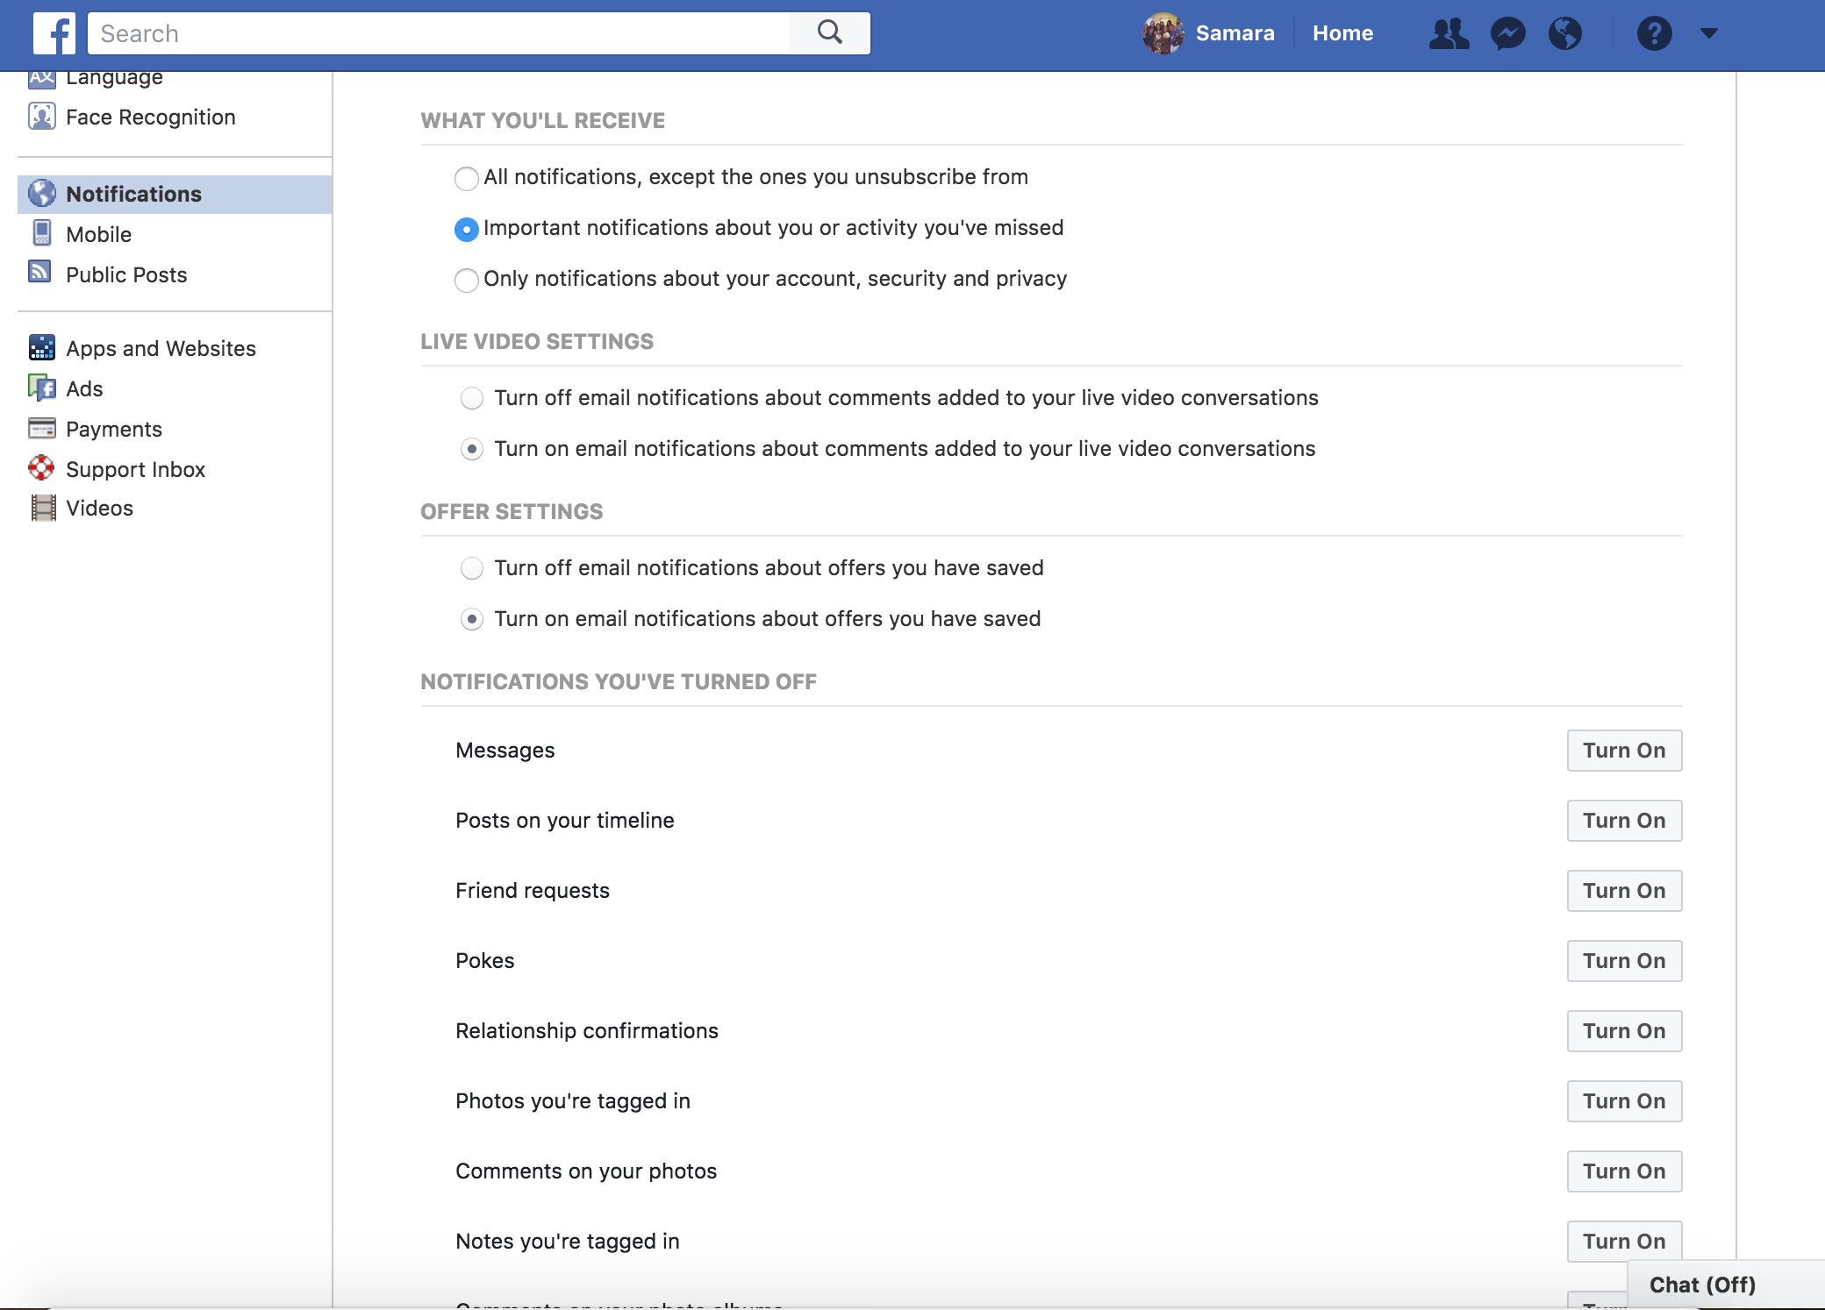

### Amazon

Amazon doesn’t have a notification center in the same way Facebook does, but the Amazon’s notification use cases more closely maps to the Vets.gov use case because notifications primarily revolve around things the users did or actions taken by Amazon.

* Notification examples:
  + **Your actions**
    - You’ve placed an order — links to a page where you can manage your order

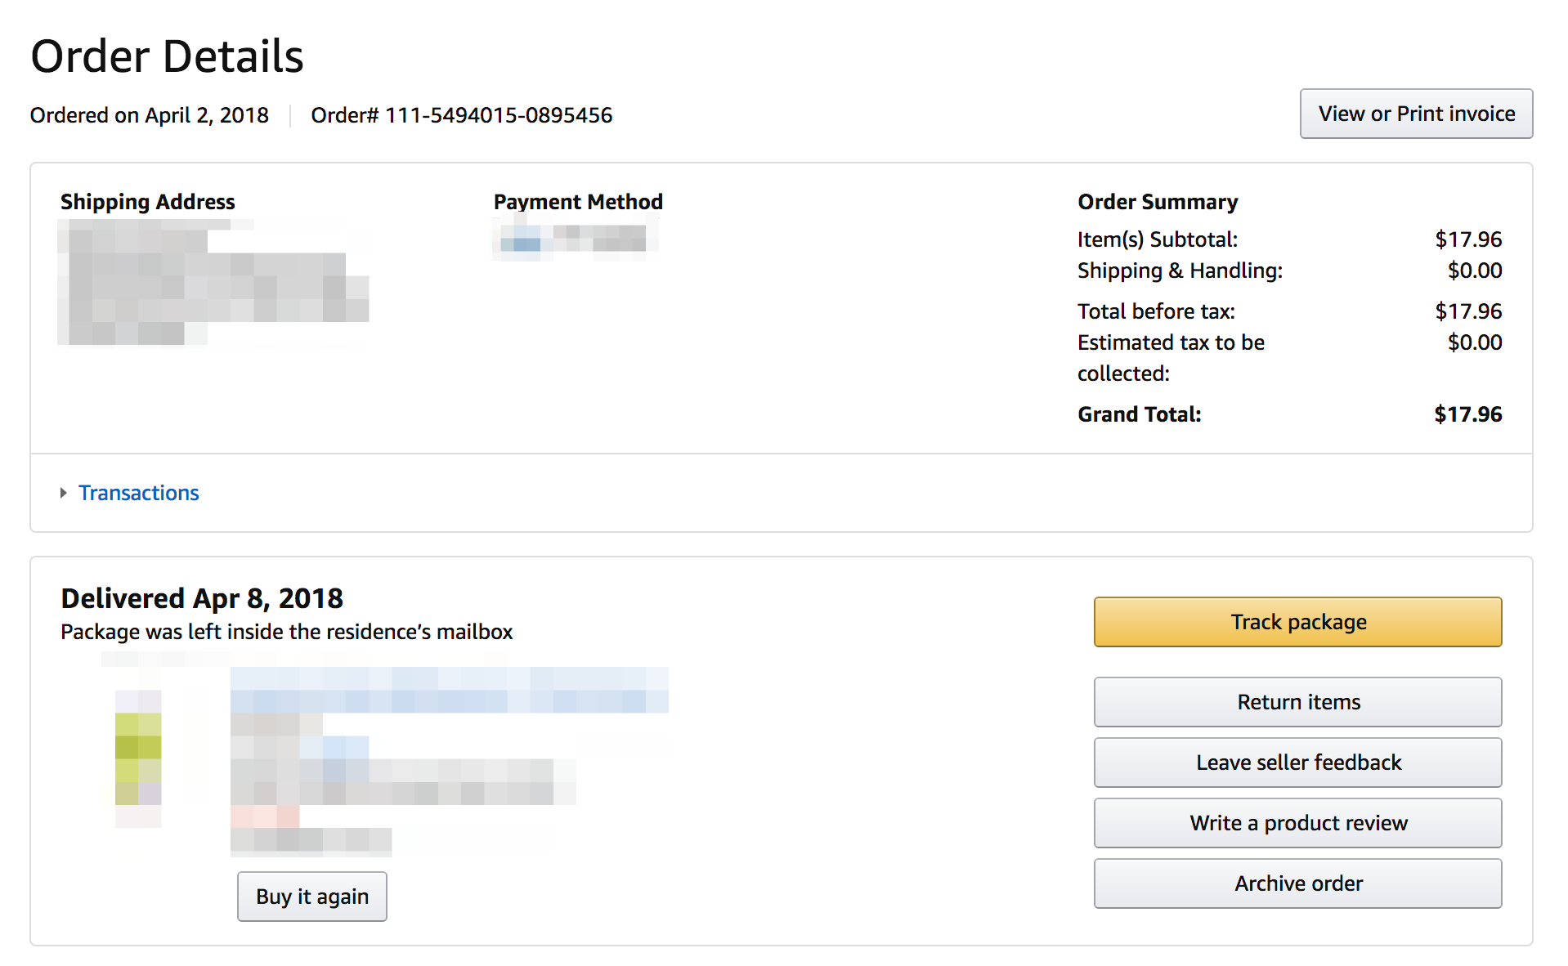

* + **Amazon’s Actions**
    - An update to your order — links to the same page above
    - Your product has shipped — links to a page where you can track an order
  + **Actions of other people**
    - Receiving a gift card
    - Buying something off of a registry
* On your Amazon dashboard, there isn’t a place for notifications. You can see some recent actions, then lots of jump off links to things you may potentially want to view or manage.

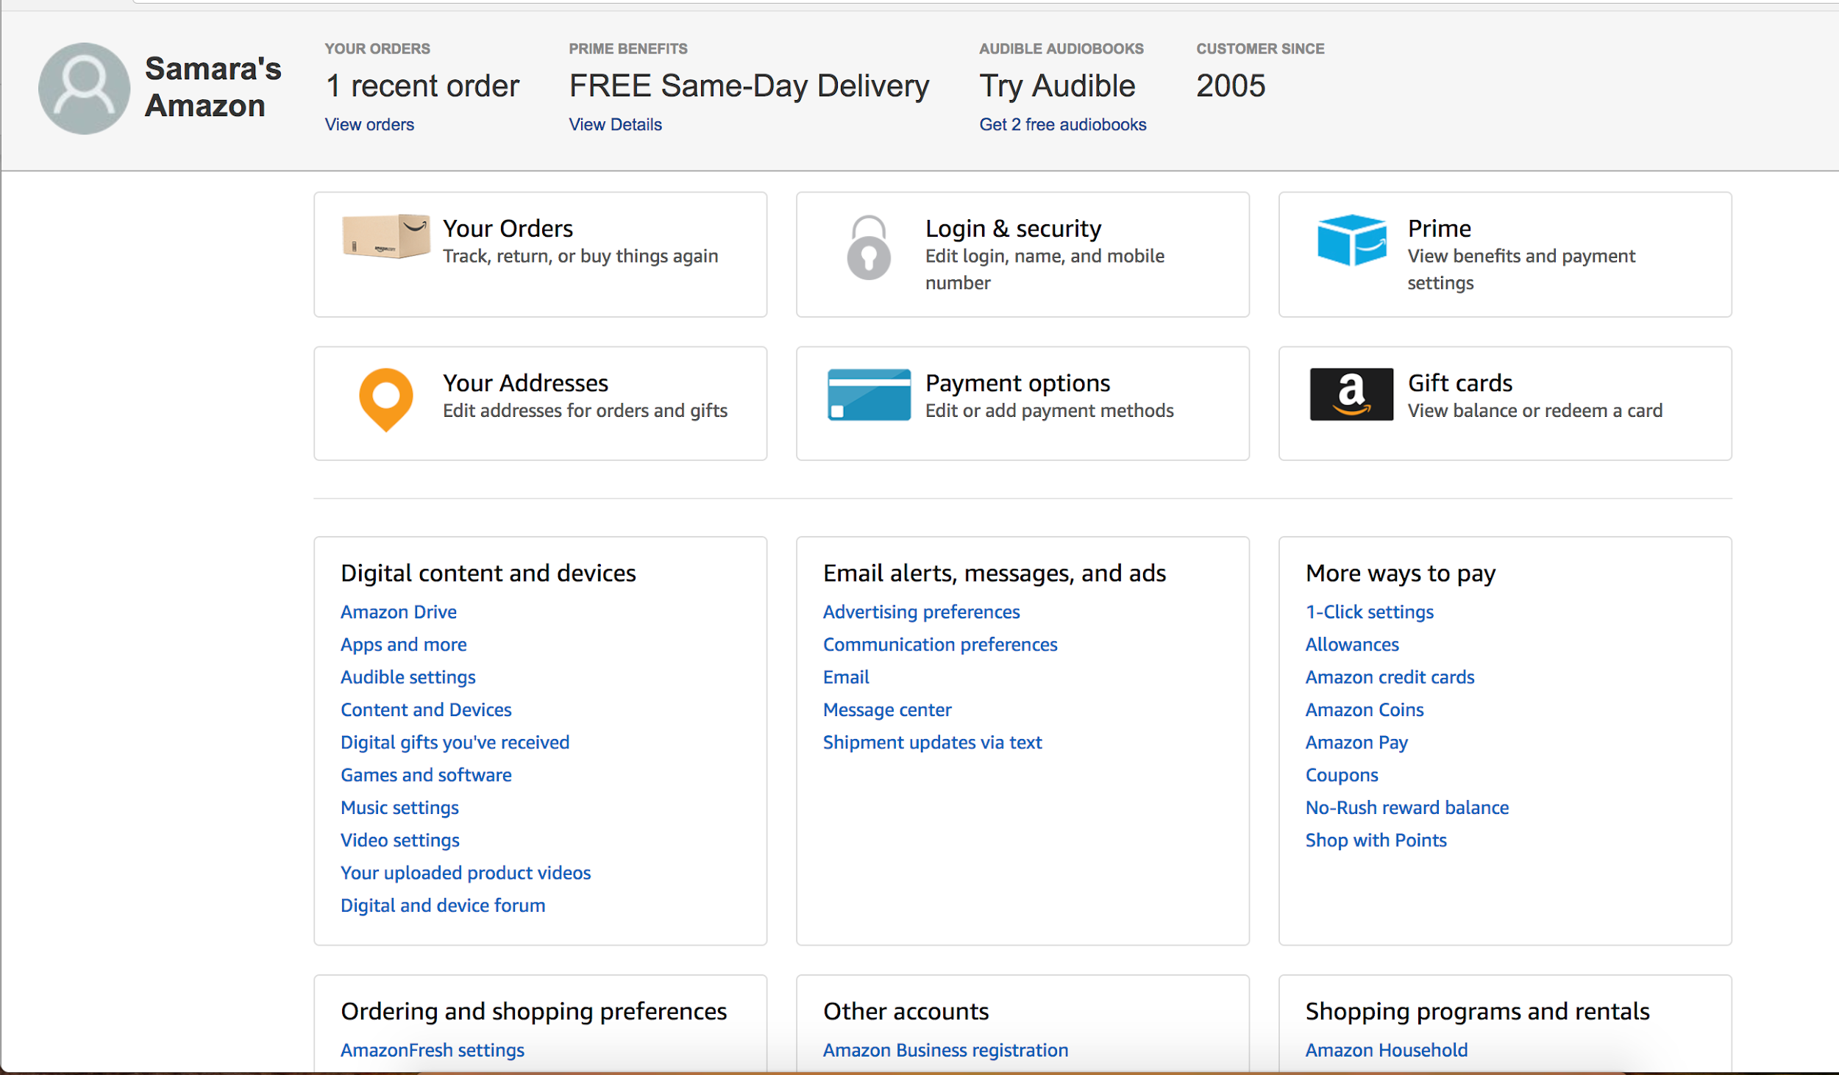

### ZocDoc

* ZocDoc has a notification menu similar to Facebook’s that highlights updates in a red box with a number in it.

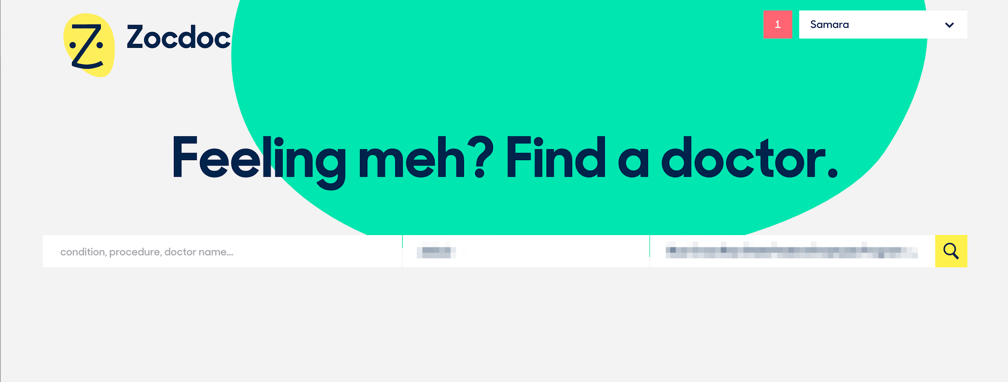

* ZocDoc’s notifications appear to be solely around things that ZocDoc wants to remind you of or get you to do. It does not appear they include actions of yours, like that you made an appointment or reviewed a doctor.
  + Notification examples:
    - Your appointment was confirmed
    - Please leave feedback for X
    - Your appointment was canceled

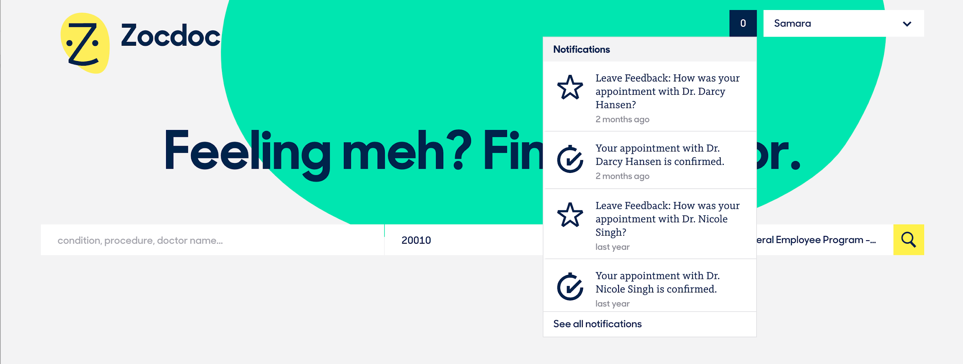

* ZocDoc also has a place where you can see historic notifications, but this doesn’t feel especially helpful. **Why do I need to see a suggestion to leave feedback for a doctor I saw three years ago?**
  + **For Vets.gov**, we should not have a place where people can see all notifications from forever. We should distinguish between being able to see historic information (eg. applications) and surfacing timely information.
* ZocDoc has very few notifications, which makes for a simple settings page. Settings are divided by email or text message, and it looks like some are only available as one kind of message.
  + **For Vets.gov**, should there be notifications that are only available as in-app OR email OR text message notifications?

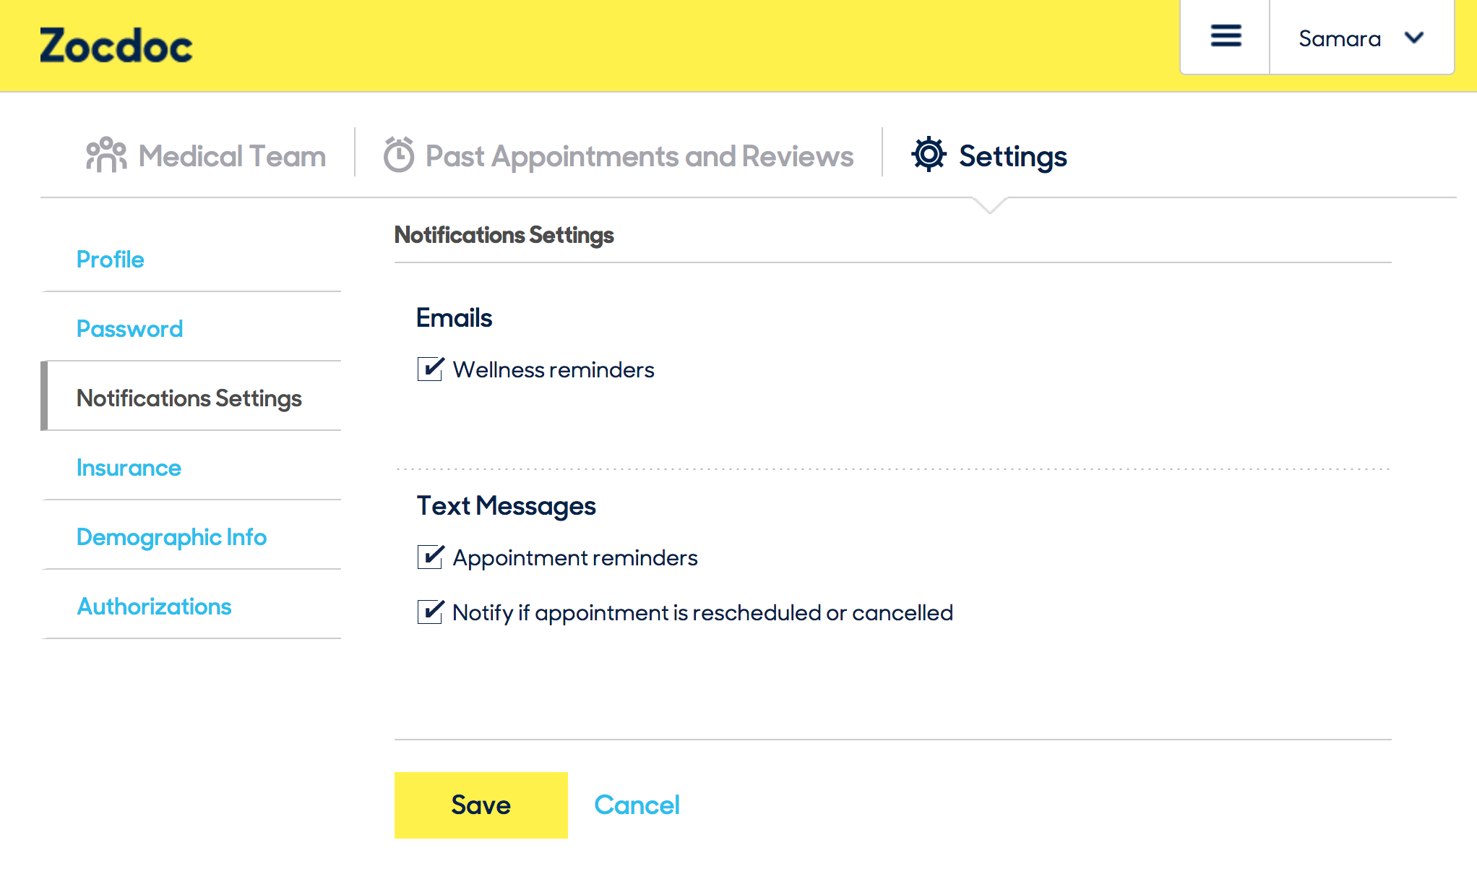

### Blue Cross/Blue Shield

Federal Healthcare Program

* FEPBlue doesn’t surface notifications contextually on the dashboard — Keeps them behind a notifications menu visible from the nav.

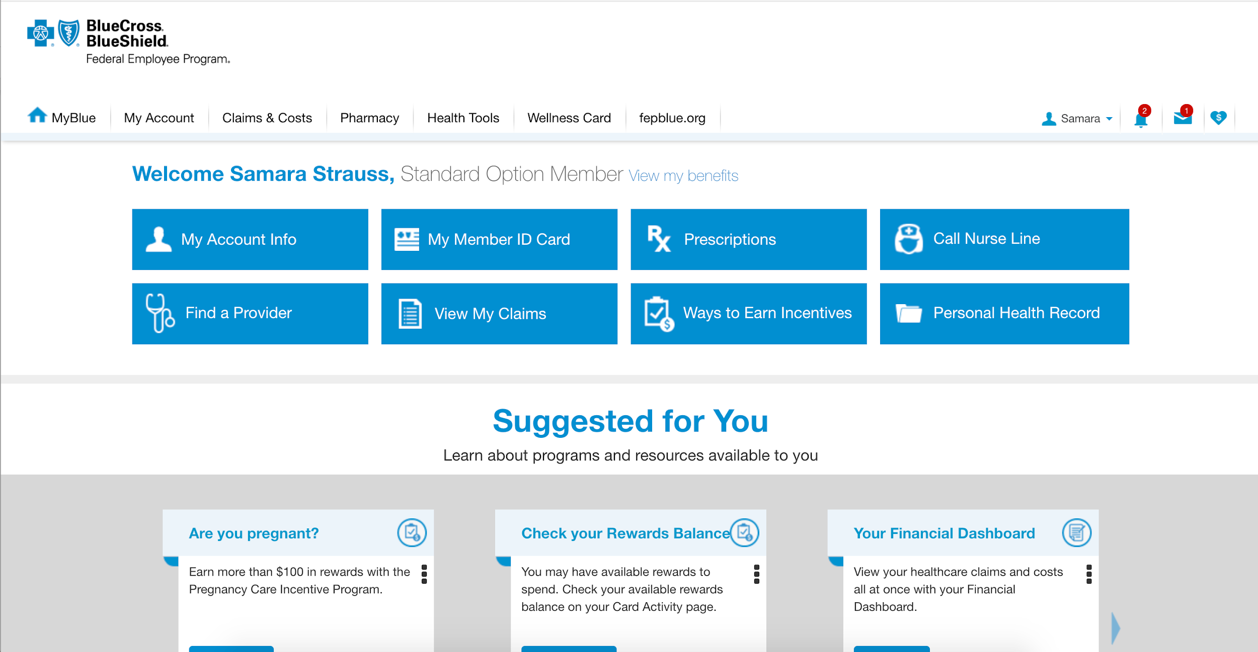

* FEPBlue divides notifications by category — things that need your action vs. notifications that are more of a heads-up. My guess would be that this kind of division isn’t really necessary, but it could be interesting to test.
* I like that the notifications have a short, scannable headline before an optional further explanation.

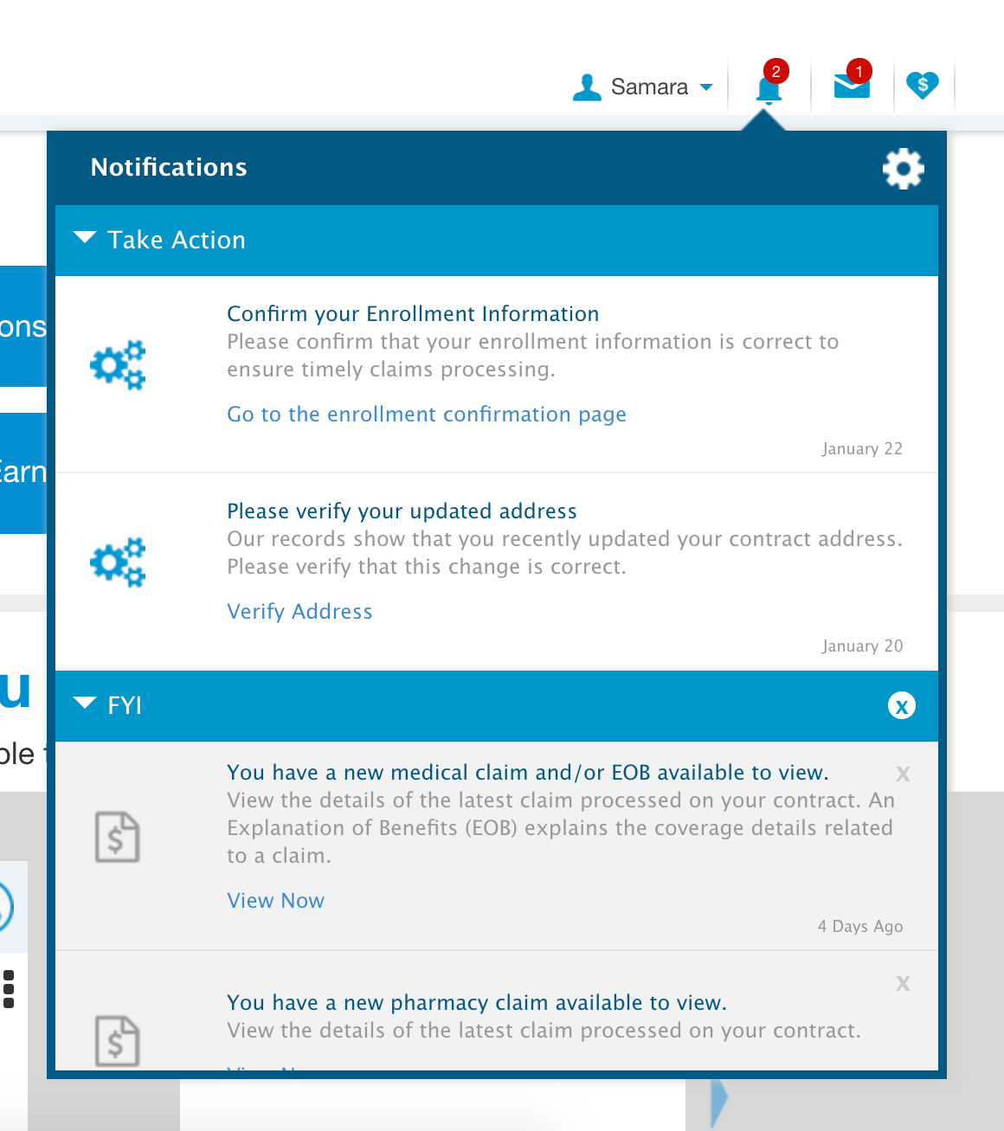

* The site has a robust settings page which gives more insight into all of the notifications available. Some interesting things:
  + You can select to receive notification over their secure messaging system instead of by mail.
  + You can batch turn on/off related groups of information.

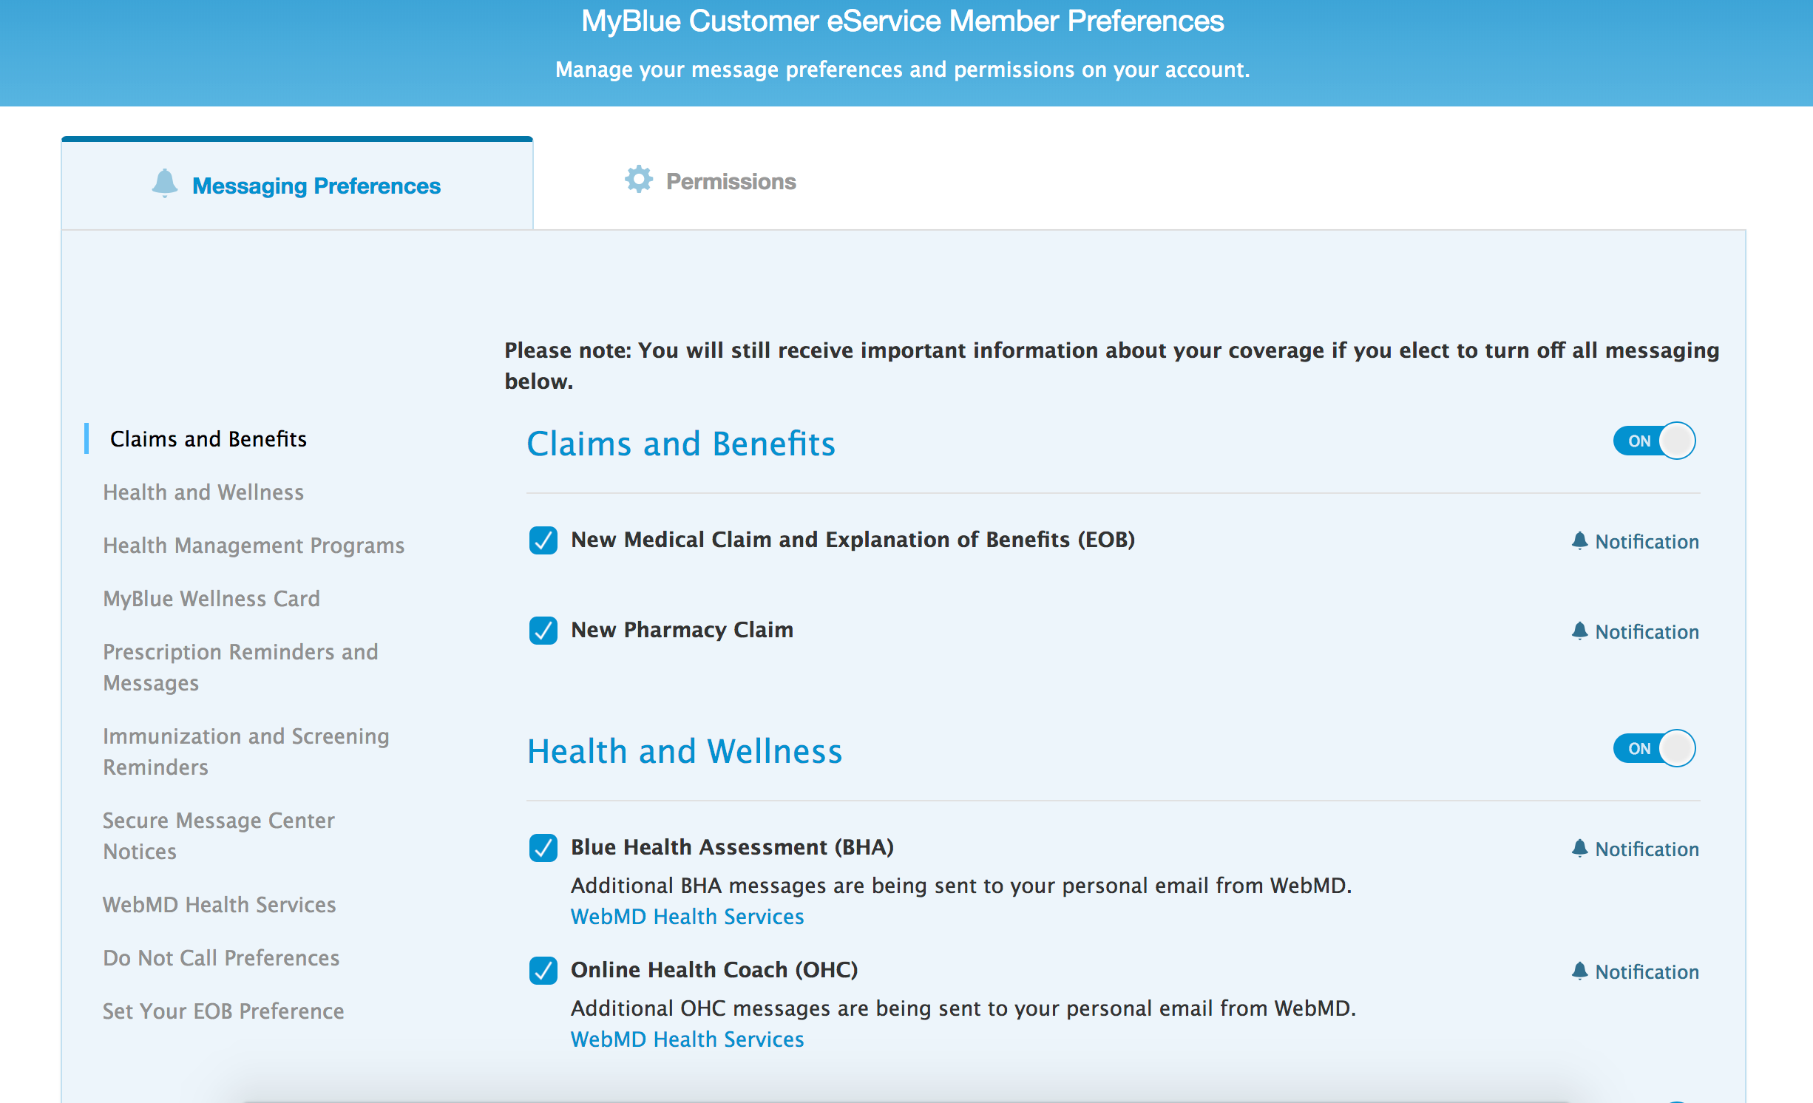

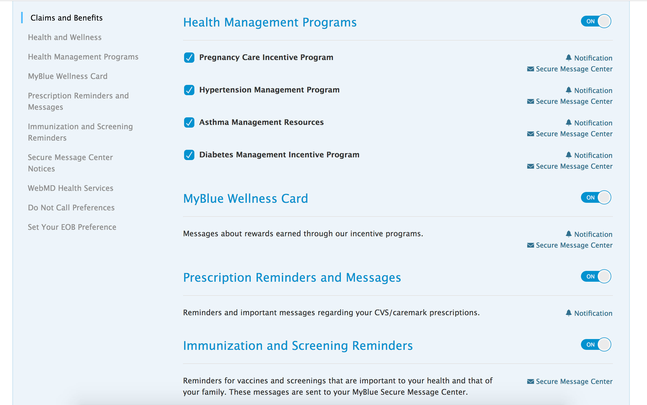

### USAA app

Not including screenshots at Lauren’s request. Here are my notes from reviewing what she sent me:

* Notifications are kept behind a profile picture on the app’s dashboard.
* From there, notifications are kept in an Inbox. I would imagine this kind of wording would be confusing on Vets.gov since there is the concept of an inbox in Secure Messages.
* It looks like notifications include things you have requested (eg. budget statements) and updates you’ve made (eg. budget updates).

### Walgreens

Nick’s notes:

*I don't have a screenshot but Walgreens uses text notifications when your prescription has been fulfilled. It's nice because it tells you enough to not need to login. It follows this template:*

*[YOUR NAME], your Walgreens prescription is READY FOR PICKUP. Visit [URL to Rx customer login] for details or call [Store phone number]. Text STOP to cancel texts.*

*When you do login, here is the dashboard. The "messages" tab contains the text message above.*

*The messages tab is the only place I see a notifications counter.*

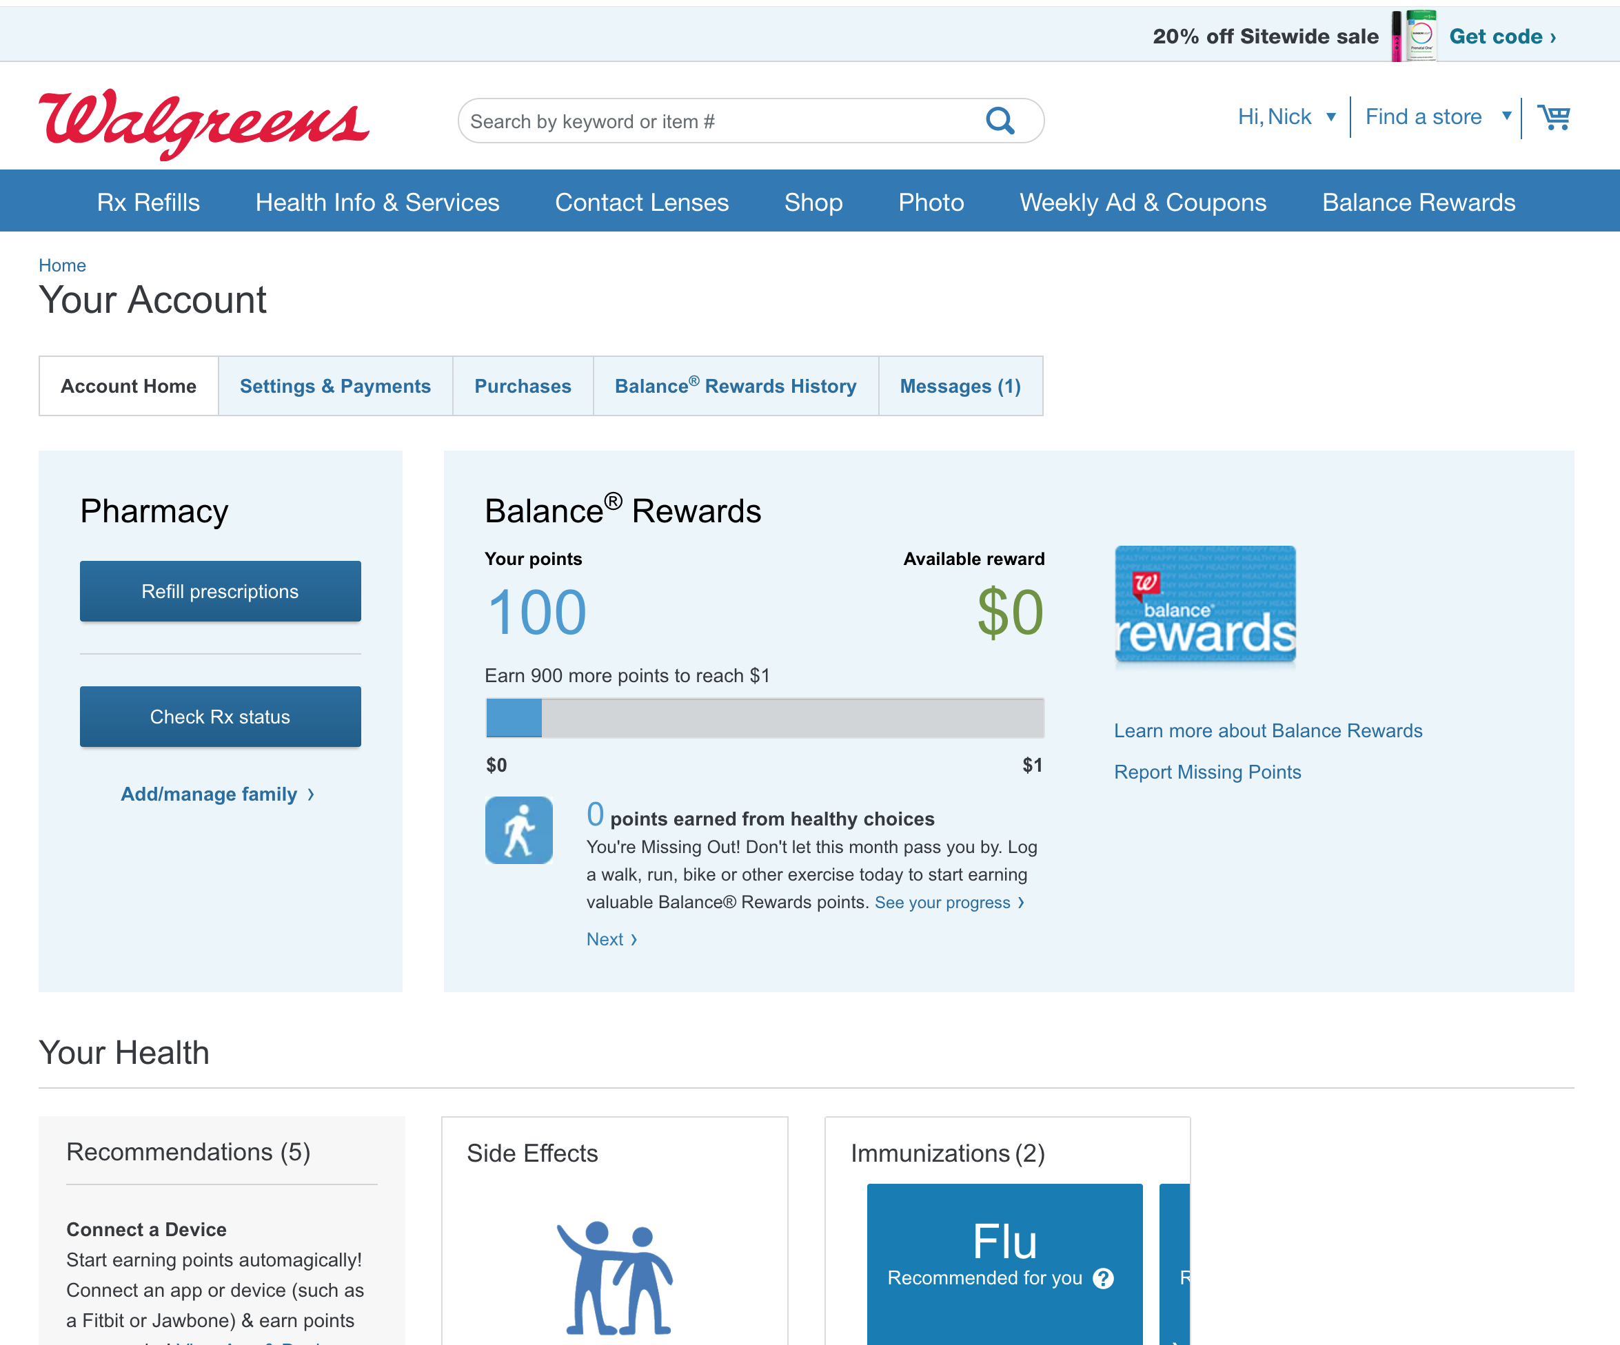

### CVS website

Ben’s notes:

*I use CVS to manage my Rx. Here's a few screenshots of their Dashboard and Account/Profile concept.*

*A few notes:*

1. *Nowhere does it store the ACTUAL message, but rather the pertinent info from the messages: "Prescriptions ready for pickup [1]"*
2. *It has a both a Homepage and "My Account" Dashboard, which are a bit duplicative but have various different functions*
3. *It has both "Messaging and Alert Settings" and "Communication Settings" which gets a bit confusing (we should make sure to avoid doing this)*

* *Messaging and Alerts is focused on how they contact you re: Rx*
* *Communication Settings is focused on how the contact you re: offers and monthly check-ins.*

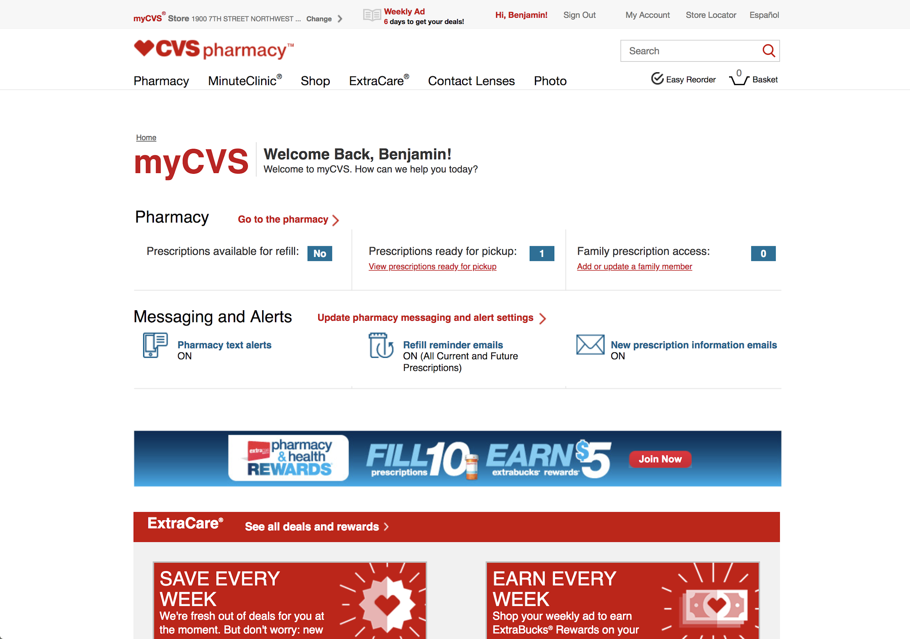

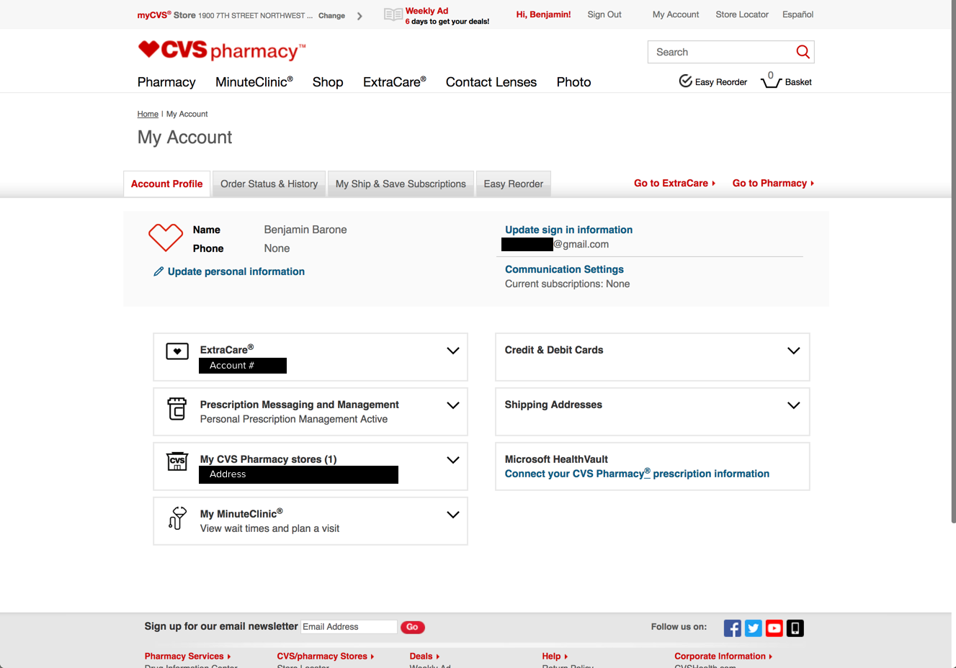

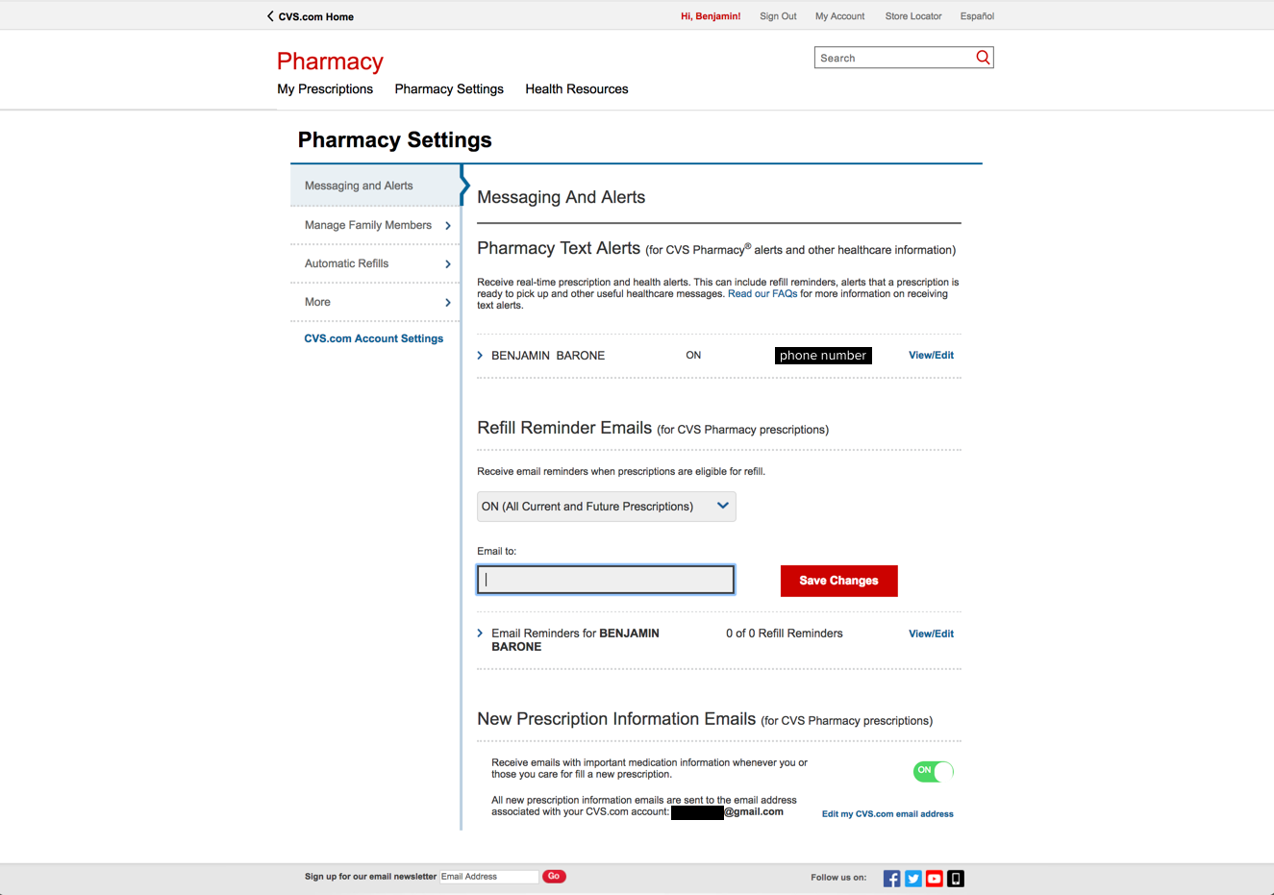

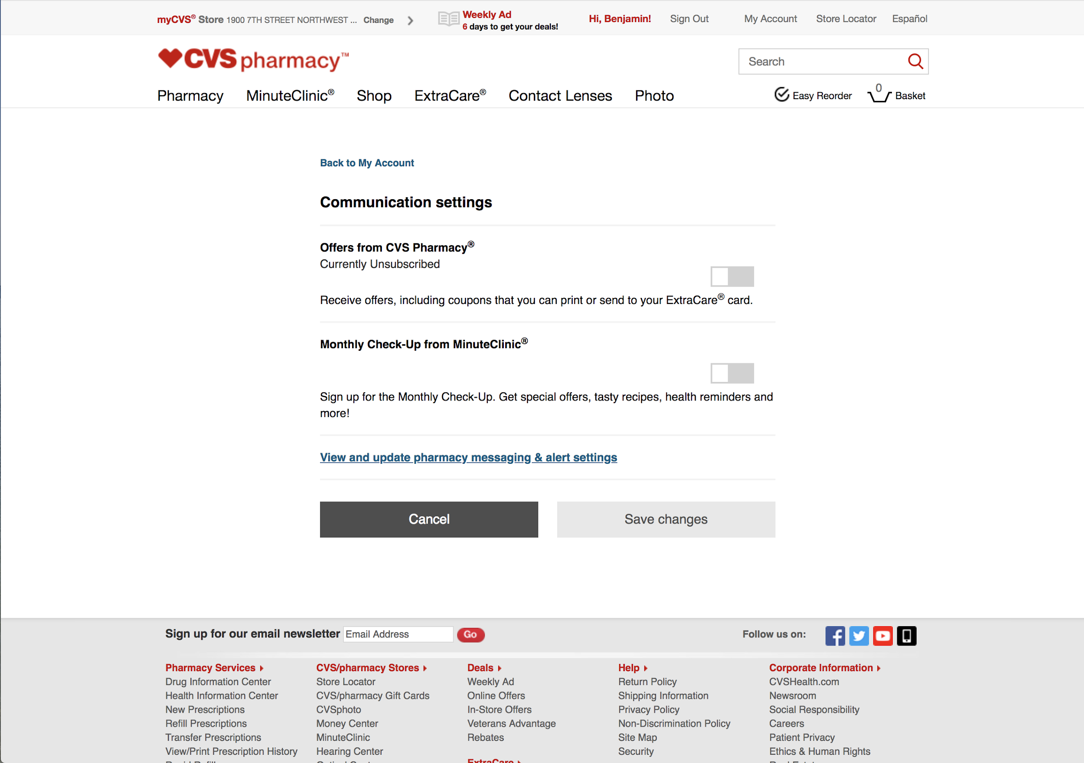

### Carefirst BlueCross BlueShield

Mel’s notes:

*I don't have any recent activity with my health care provider to show :( but here's at least the structure around notifications (just not much actual content):*

Samara’s notes:

* Can’t tell much without real content, but it looks like notifications and messages are kept separately.

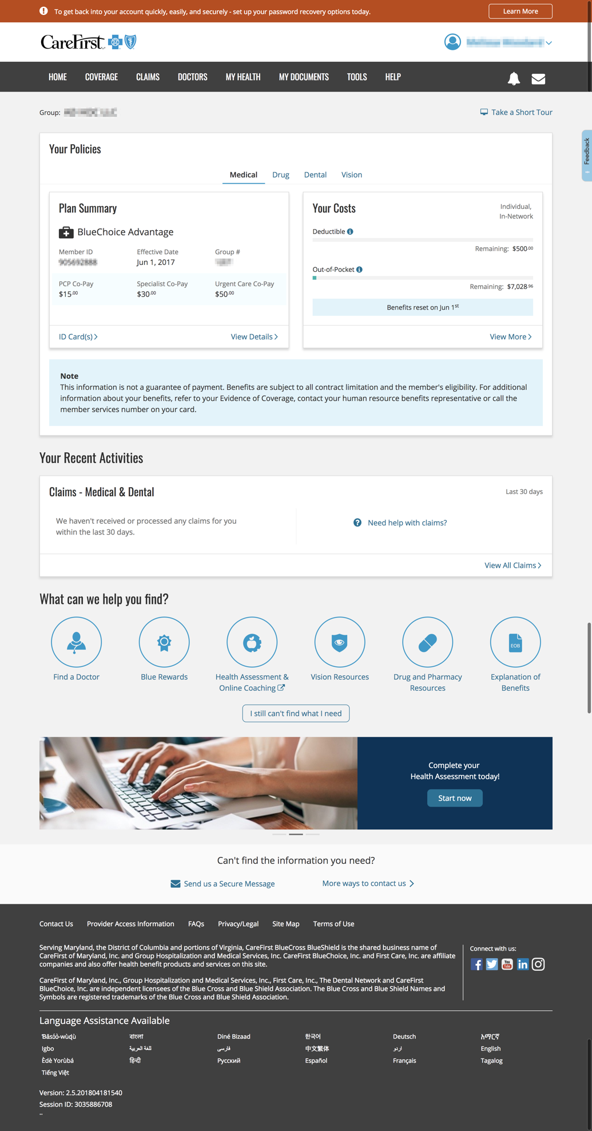

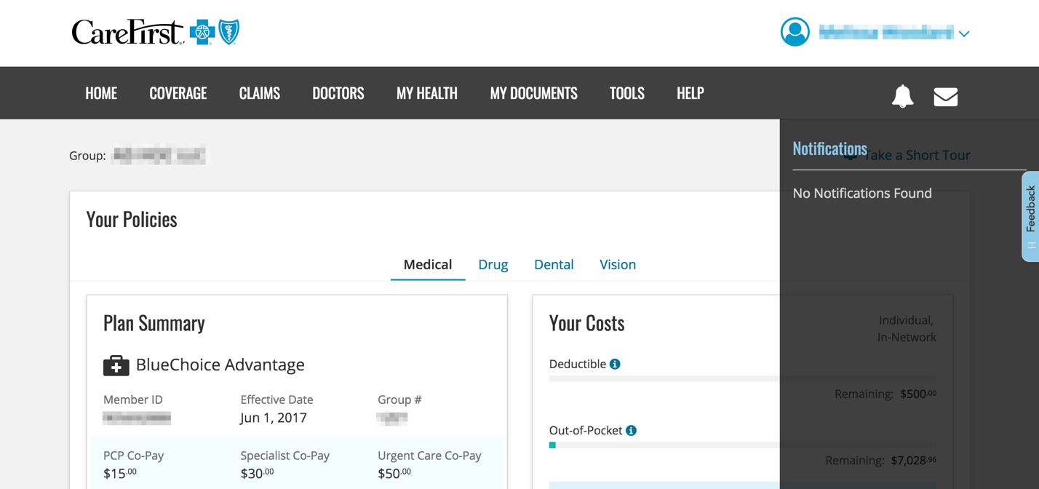

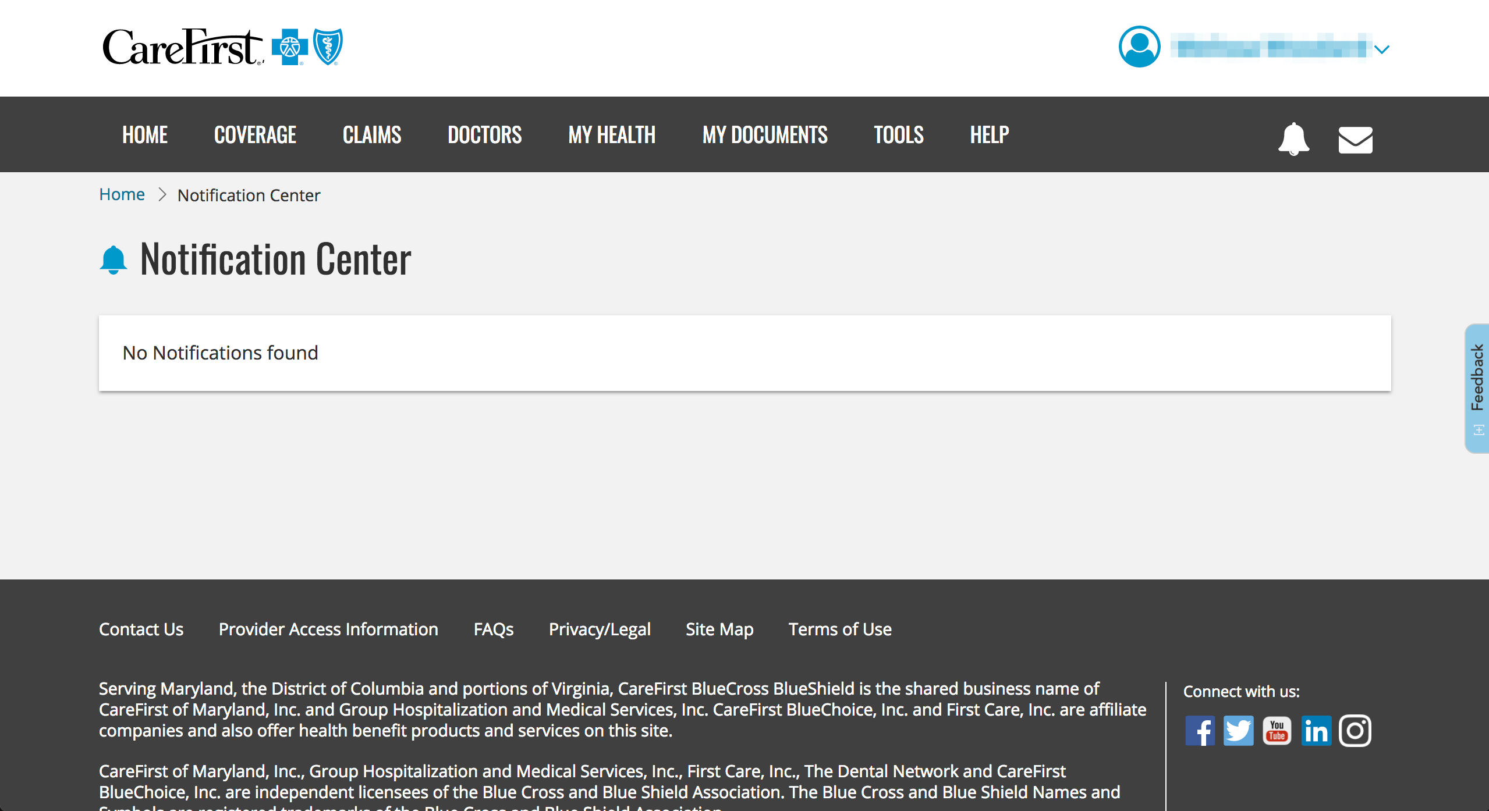

### Airbnb

Mel’s notes:

*Airbnb groups messages and notifications tightly together. Seems like the distinction is****messages*** *are conversations between you and another person, whereas****notifications****are things the Airbnb system is prompting you to do or updating you on. This dropdown appears when I click on messages in the navigation:*

Samara’s notes:

* **Since messages are a very specific thing in the VA digital universe, we’ll also keep notifications and messages separate**.
* However, this makes me think again about a hierarchy if there happened to be a notifications page… do we need some sort of distinction between different types of messages?

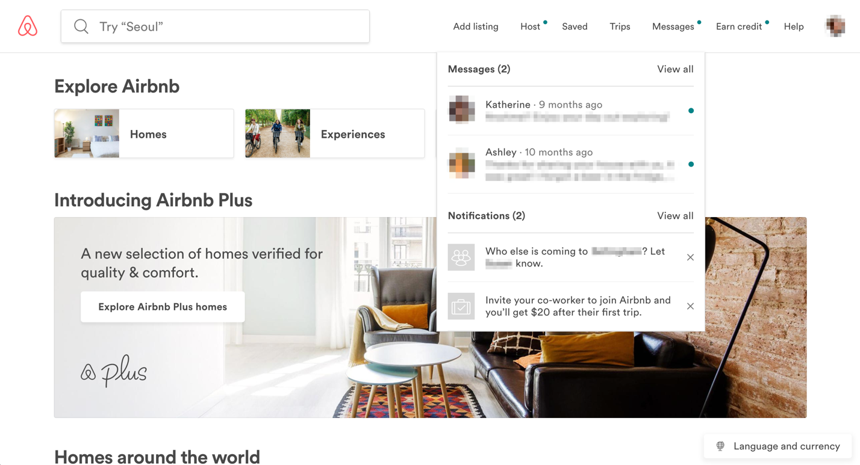

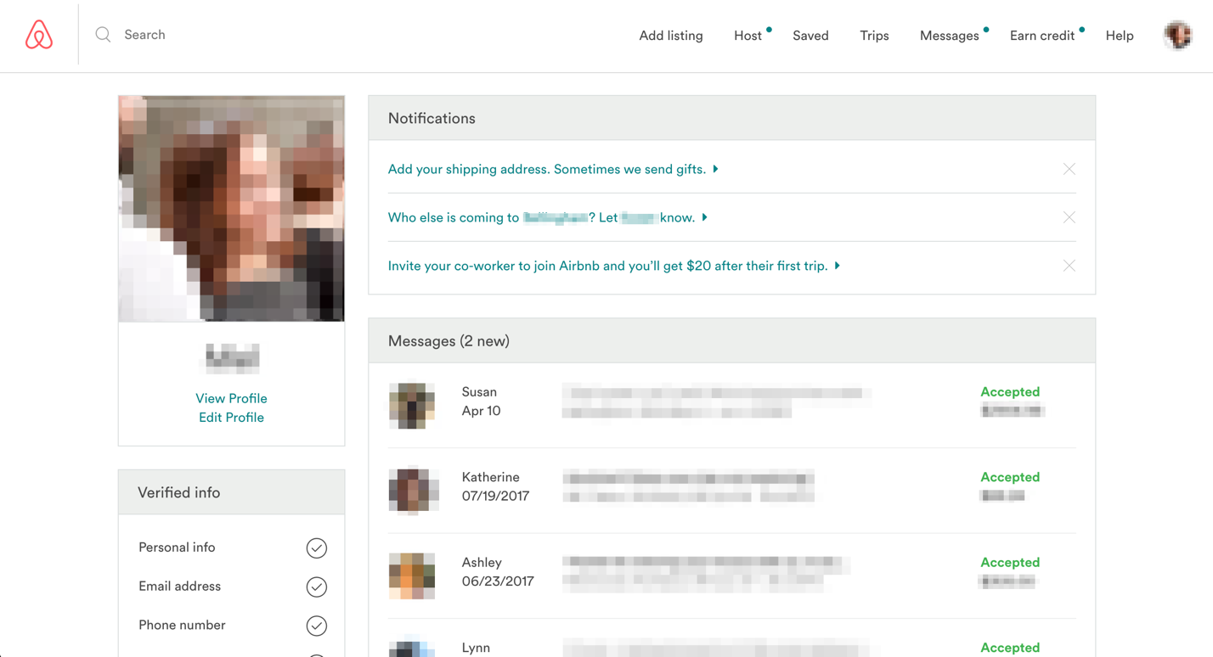

### Nelnet

Mel’s notes:

*Nelnet seems to be in a similar boat to us, with a dashboard-like page that surfaces important status updates. Their "notifications" that get bumped to the top seem to be things that are (a) potentially time-sensitive and (b) don't fit into the other blocks of the dashboard.*

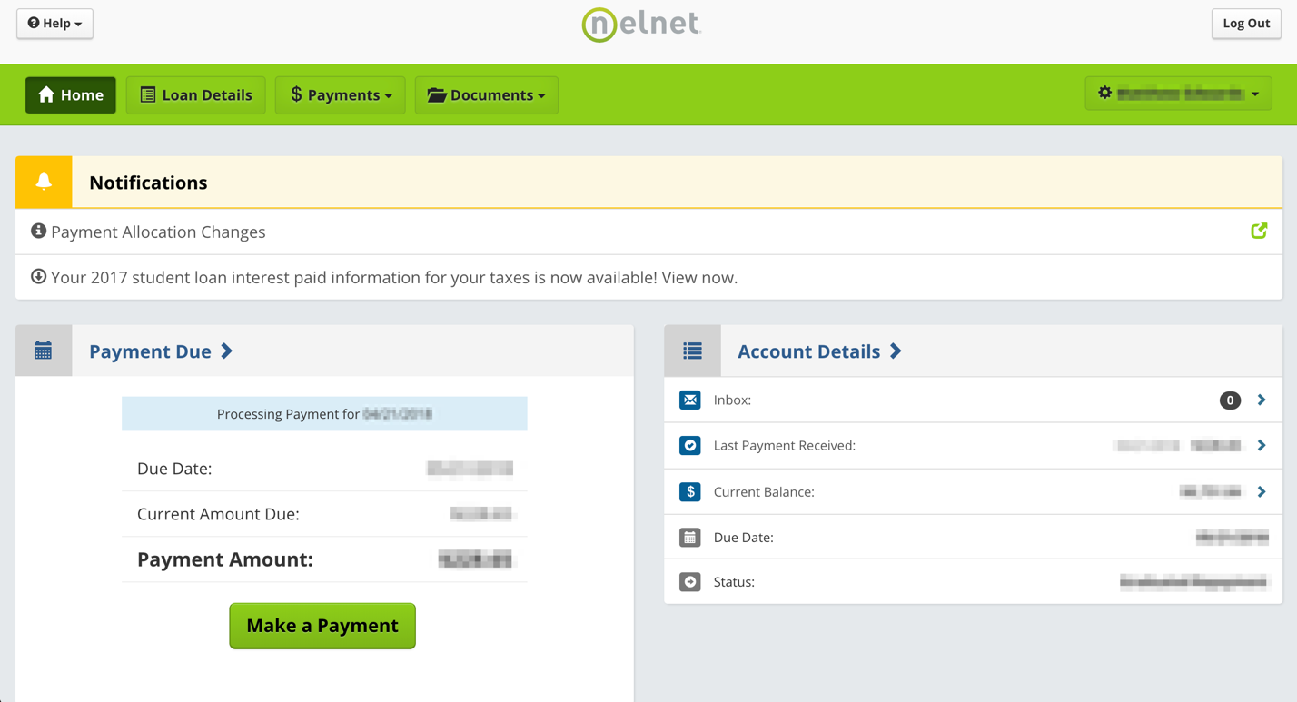

*Here's the click-through on the first notification - the second one takes you through to the page where you can view tax info.*

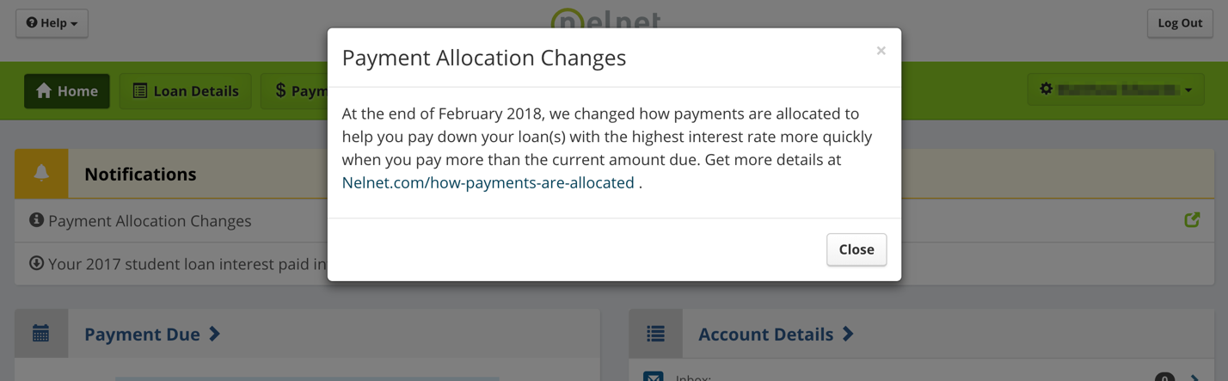

### Conclusions

* **Hypothesis**: We do not need a page that shows all historic notifications forever.
  + May want to test this if we determine it’s worthwhile.
* A notification center/newsfeed is not the place to see actions you’ve taken (eg. You applied for healthcare benefits). These should be chronicled in their separate sections, which will be accessible from the new dashboard.
* Notification center should only be for:
  + Things VA has done (eg. Updated a claim; added an item to your eFolder, etc)
  + Reminders
* Like other content on Vets.gov, notifications should have short, scannable headings whether there is copy that explains things further or not.

**Things to consider**

* How do we determine whether a notification has been seen?
* What do settings and preferences look like for in-app notifications? How does this overlap with email notification settings?
  + **For Vets.gov**, what is the line between what we let people opt out of and what is an automatic notification? Do we need to allow the option to turn off in-app notifications, too?
* Option 1: Style notifications differently on the dashboard. No separate notification center.
  + Problem: What if there are more notifications that blocks on the dashboard?
* Option 2A: Have a notification center that highlights updates, but do not highlight these updates on the dashboard.
  + Updates (likely) would also show on the dashboard but they would not have any kind of notification indicator.
* Option 2B: Have a notification center that highlights updates, but DO highlight these updates on the dashboard.
  + Updates (likely) would also show on the dashboard and they **would** have a notification indicator.
* **Remember, people are not hanging out on Vets.gov like they do Facebook**. They will likely not have as many notifications as they would on a social media site.
* **To test**: Should we separate messages and other notifications in a notification center? What about dividing notifications by other categories?